## **Lab 16: Android Video Player**

# **Introduction**

We can stream video files in Android by using the MediaController and VideoView classes.

**MediaController Class**

The android.widget.A view called MediaController includes media controls like play/pause, previous, next, fast-forward, and reverse.

**VideoView Class**

The android.widget.The methods to play and manage the video player are provided by the VideoView class.

**Let’s get Started:**

This example shows how to create a Video Player class to create a straightforward Video Player in an Android Kotlin application.

**Step 1:** open **activity_main.xml** file from **\res\layout** folder path and write the code like as shown below.

**activity_main.xml**

*<?*xml version="1.0" encoding="utf-8"*?>*<RelativeLayout xmlns:android="http://schemas.android.com/apk/res/android"  
 xmlns:app="http://schemas.android.com/apk/res-auto"  
 xmlns:tools="http://schemas.android.com/tools"  
 android:layout_width="match_parent"  
 android:layout_height="match_parent"  
 tools:context=".MainActivity">  
  
 *<!-- creating a video view on below line-->* <VideoView  
 android:id="@+id/idVideoView"  
 android:layout_width="match_parent"  
 android:layout_height="wrap_content"  
 android:layout_centerInParent="true" />  
  
</RelativeLayout>

**Step 2:** Open main [activity](https://www.tutlane.com/tutorial/android/android-activity-lifecycle) file **MainActivity.kt** and write the code like as shown below.

**MainActivity.kt**

**package** com.example.demopluarlsightvideoplayer  
  
**import** android.net.Uri  
**import** android.os.Bundle  
**import** android.support.v7.app.AppCompatActivity  
**import** android.widget.MediaController  
**import** android.widget.VideoView  
  
  
**class** MainActivity : AppCompatActivity() {  
  
 *// creating variables for video view on below line.* **lateinit var videoView**: VideoView  
  
 **override fun** onCreate(savedInstanceState: Bundle?) {  
 **super**.onCreate(savedInstanceState)  
 setContentView(R.layout.*activity_main*)  
 *// initializing variable for video view on below line.* **videoView** = findViewById(R.id.*idVideoView*)  
  
 *// creating and initializing variable for media controller on below line.* **val** mediaController = MediaController(**this**)  
 *// setting media controller anchor view to video view on below line.* mediaController.setAnchorView(**videoView**)  
 *// on below line we are getting uri for the video file which we are adding in our project.* **val** uri: Uri = Uri.parse(**"android.resource://"** + *packageName* + **"/"** + R.raw.*video*)  
 *//on below line we are setting media controller for our video view.* **videoView**.setMediaController(mediaController);  
 *// on below line we are setting video uri for our video view.* **videoView**.setVideoURI(uri);  
 *// on below line we are requesting focus for our video view.* **videoView**.requestFocus();  
 *// on below line we are calling start method to start our video view.* **videoView**.start();  
 }  
}

**Step 3: Check Output on Android Emulator and it should look like as given below.**

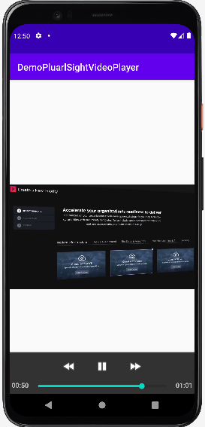 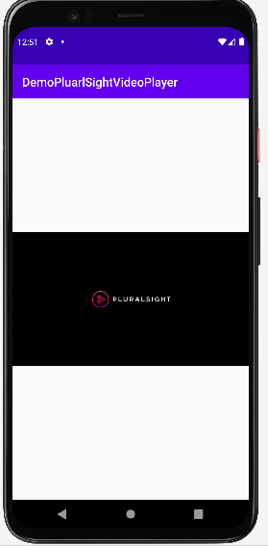

**Voila!!** We have successfully completed this lab.